ID#: 2408098
Full Name: Daniel Brown
Assignment #: IA2
Day/Time of Class: Mondays 3:00 PM
Module Name/Code: Web Development 1 / CIT 2011 UM1

Storyboard
Home Page (index.html)
- Navigation Bar (Links to all pages)
- Hero Section (Call to Action)
- Footer

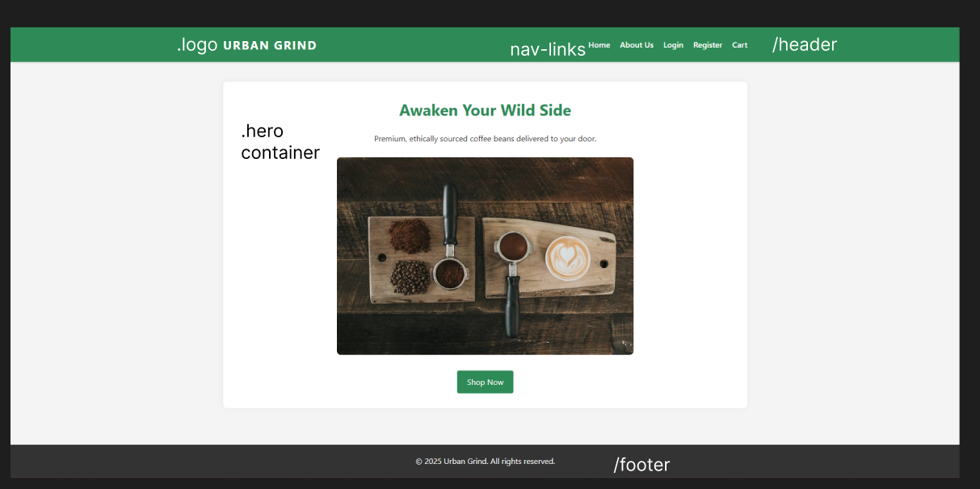

About Us (about.html)
- Business Description
- Student/Developer Details
- Contact (Mailto link)

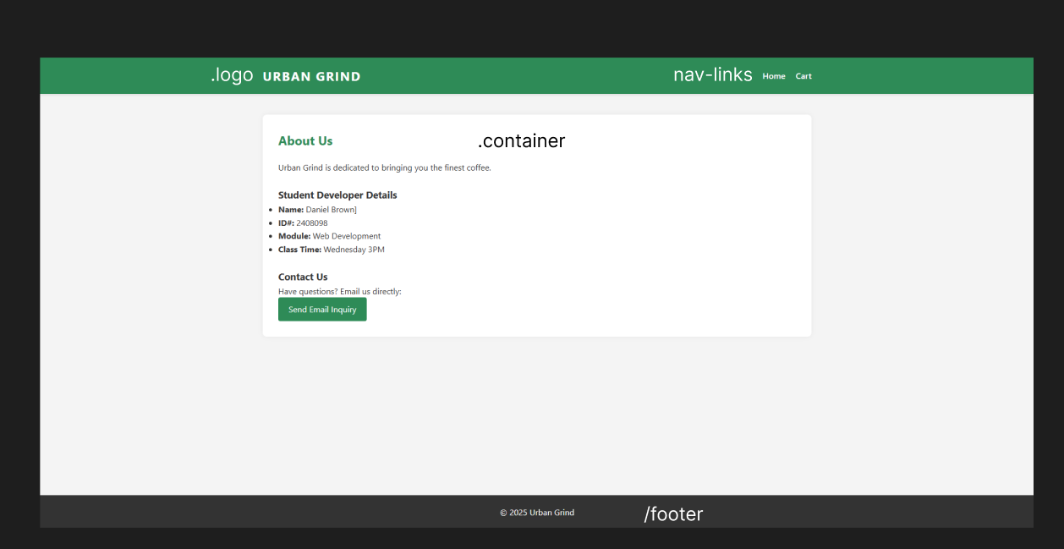

Account Management
- Login (login.html)
- Register (register.html)

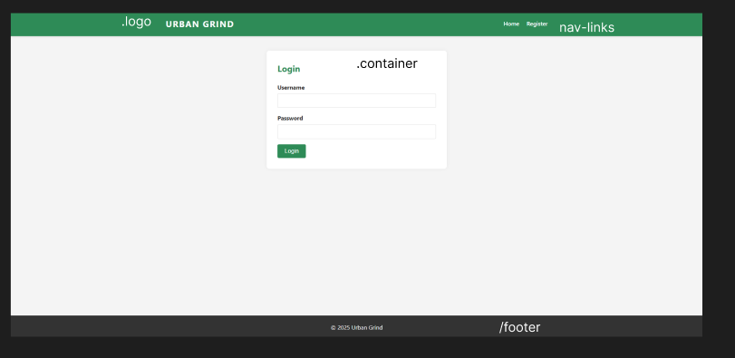
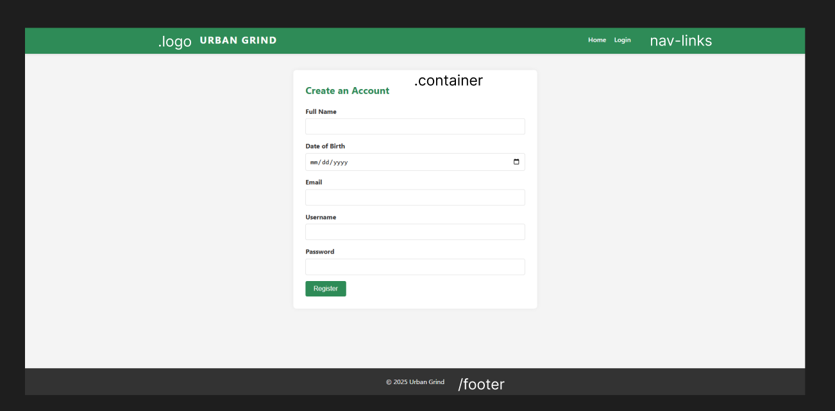
Shop Flow
- Shop/Products (shop.html)
  - Action: Add to Cart
- Cart (cart.html)
  - Action: Proceed to Checkout
- Checkout (checkout.html)
  - Action: Confirm Order
- Invoice (invoice.html)

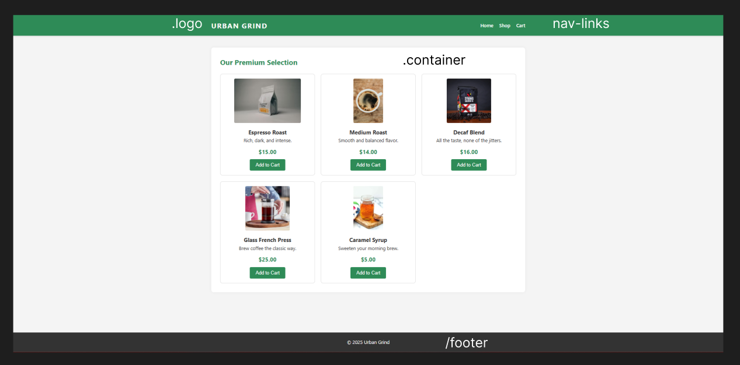
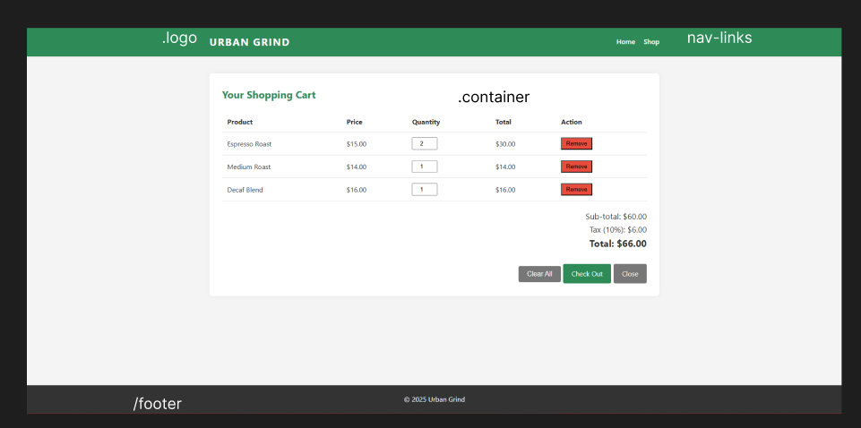
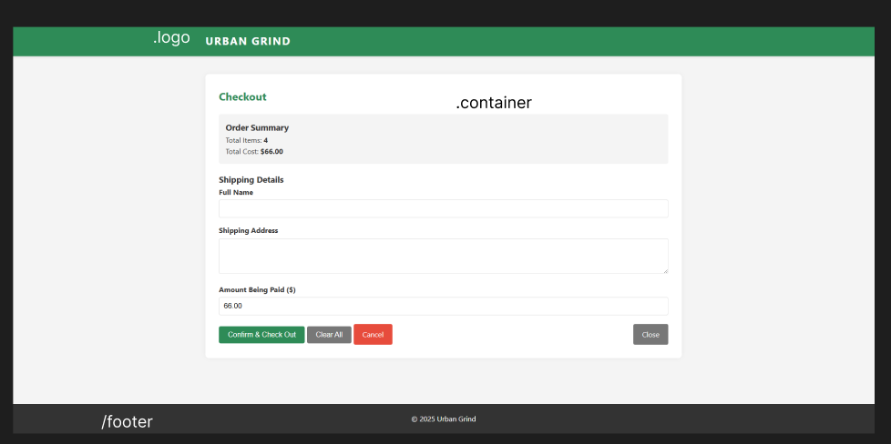

The design of the site is a traditional "F-Layout" for e-commerce:
1. Header (Top) - A centered "Urban Grind" logo on the left side and a navigation menu on the right (Home, Shop, Cart, Login).
2. Main Body (Middle) - Home, a large Hero Image and with a centered button to shop; Shop a responsive grid with containers displaying a grid of product cards with a image, title, price, and an "add to cart" button. All pages designed for log-in/register/checkout have a centered container with clear input field labels /action buttons.
3. Footer (Bottom) - A dark persistent bar with copyright notice.

Business Description
Business Name: Urban Grind
Slogan: "Awaken Your Wild Side."
Mission Statement: To serve the freshest coffee, sourced ethically, that energizes while being cognizant of the planet.
Vision Statement: To become the premier sustainable coffee brand among Caribbean students and professionals.
Logo Vision: The name "Urban Grind" stated in a bold lettering, sans-serif typeface to show stability and a green color palette to reflect nature.

iii. Justification of Color Palette (Psychology of Color)
The color palette for Urban Grind was based on color psychology research conducted by Envato (2021).
Primary Color: Green (#2E8B57)
Rationale: Green represents "the color of balance" and is situated in the color spectrum (Envato, 2021). Green represents nature, health, and freshness - the green coloration serves to reinforce that we are committed to organic coffee beans. The video provides that green is the most comfortable color for the human eye and this will provide ease and a pleasant experience for our customers who are inspecting product in the shop. • Secondary Color: White (#FFFFFF)
o Rationale: White was utilized for background and negative space. As indicated in the video, white represents cleanliness, purity, and simplicity (Envato, 2021). This provides a clean slate that makes the product images pop and reflects the sophistication of international brands like Apple.
• Accent/Text Color: Dark Grey/Black (#333333)
o Rationale: Black and dark grey are utilized for text and footers. The video describes black as sophistication, power, and timelessness (Envato, 2021). By using dark grey and not black, we provide comfort to the eyes while achieving brightness, contrast and legibility.

iv. Intended Audience
The target audience for Java Jungle includes:
- University students, 18 – 25 year-olds who utilize caffeine in order to study during the day, and who stay up all night to use caffeine. The target market is most likely very technology savvy and would respond positively to a mobile-first site with fast load times.
- Young professionals, 25 - 35 year-olds who enjoy premium products along with online ordering and delivery.
- Eco-conscious customers who value sustainability and organic products drawn to the Green/natural brand concept.

References
Video Source: Envato. (2021, March 18). Color Psychology | Red, Blue, Yellow, Green, Pink, White, Black, Gray and Gold [Video]. YouTube. https://www.youtube.com/watch?v=8J0nbuunDXc
Image Sources:
- Espresso Roast Image: Nix, T. (2019). Clear glass cup filled with coffee [Photograph]. Unsplash. https://unsplash.com/photos/nI4AgC4R6Ea
- Medium Roast Image: Di Bella Coffee. (2017). Coffee beans in sack [Photograph]. Unsplash. https://unsplash.com/photos/ukVGqrwEqvM
- French Press Image: Koprivak, S. (2018). French press coffee maker [Photograph]. Unsplash. https://unsplash.com/photos/tNALOIZHQLM
- Syrup/Latte Image: Harris, C. (2021). Iced caramel latte [Photograph]. Unsplash. https://unsplash.com/photos/1c44b15718ee

